Overview

Agile Software Development
Software development is the process of creating and maintaining applications and frameworks resulting in a software product.
As our projects are complex domain (evolving requirements and unclear technology needs) and we need to reduce risk of the project failure, we chose to develop the software in agile software development process. We use a tailored version of Scrum with some inspiration from Feature Driven Development (FDD).
Agile software development is an approach to software development under which the requirements and the development evolve through the collaborative effort of self-organizing and cross-functional teams and their sponsors/stakeholders/customer(s)/end users(s). It promotes continuous iteration of incremental software, which encompasses adaptive planning, evolutionary development, early delivery and continuous improvement.
Scrum is an interactive and incremental agile software development framework to manage product/project development. Scrum is an agile framework for completing complex domain projects. It works well for any complex and innovative scope of project.
The following three roles are defined in Scrum:
Product Owner:
Has the product vision, the knowledge about all the requirements (stories) and the business value for the customer. The Product Owner has a very clear vision about the final product and how it should work. He/she may be the customer or another person who has the customer vision about the product.
Development team:
The team, with an ideal size between 3 and 9 members, has the target to build the product. It’s a cross-functional and self-organized team with all the skills and knowledge needed to develop the product. Each team member must adapt to the needs of the team at every moment.
Scrum Master:
Has an excellent knowledge of Scrum methodology, his/her objective is to help and support the team and the product owner in applying Scrum. This includes answering any kind of questions and doubts about the use of the framework and isolating the Scrum team from other external problems. He/she is not a leader but a mentor (called servant leader). He/she is responsible to facilitate scrum ceremonies.

Four artefacts of scrum:
Product Backlog:
The product backlog is a single source of requirements (stories), bugs, and change requests from all stakeholders. This product backlog is sorted by business value of the customer and by risk involved. The Product Backlog is never complete, it only lays out the known and best understood requirements. Product Backlog is dynamic; it consistently changes to identify what the product needs to be useful.
Product Backlog Template
Task ID | Story | Estimate | Priority | Risk Severity
1 | Story statement, short description | 4 | 1
2 | Story statement, short description | 6 | 2
3 | Story statement, short description | 3 | 3
4 | Story statement, short description | 5 | 4
5 | Story statement, short description | 5 | 5
6 | Story statement, short description | 7 | 6
7 | Story statement, short description | 4 | 7
8 | Story statement, short description | 3 | 8
9 | Story statement, short description | 2 | 9
10 | Story statement, short description | 1 | 10

Sprint Backlog:
The Sprint Backlog is the subset of Product Backlog items selected for the Sprint (iteration) plus a plan for delivering the product Increment and realizing the Sprint Goal. The Sprint Backlog is a forecast by the Development Team about what functionality will be in the next Increment and the work needed to deliver that functionality. The Sprint Backlog makes visible all of the work that the Development Team identifies as necessary to meet the Sprint Goal.
Sprint Backlog Template
Task ID | Story | Estimate | Priority | Status
1 | Story tasks statement, short description | 4 | 1
2 | Story tasks statement, short description | 6 | 2
3 | Story tasks statement, short description | 3 | 3
4 | Story tasks statement, short description | 5 | 4

Kanban Board Template
Start date: | Development team name | End date:
To-do | Doing | Done
Task statement | Task statement | Task statement
Task statement

Definition of Done:
When the Product Increment is delivered, it needs to meet “Definition of Done” which is a shared understanding of the development team regarding of what “DONE” means. This definition is different for every Scrum Team. This is jointly developed by the scrum team, which consists of the development team, scrum master and product owner.
Product Increment:
The most important Scrum artefact is the Product Increment. Each Sprint/Iteration the development team produces potentially shippable product increment. This product increment must align to the development team’s “Definition of Done” and this increment must be acceptable by the Product Owner.
Feature Driven Development (FDD): Is a development process, which is oriented around delivery in small blocks (Features) of valued project. This is an iterative and incremental software development process having the main purpose of delivering tangible working software repeatedly in a timely manner. It can track down the project progress with precision.

Mapping IEC 62304’s activities to Agile Development
The standard IEC 62304 defines a software development process model with a well-established set of activities necessary to develop medical device software. The figure below illustrates how these activities are being performed when following an Agile life cycle such as the one being proposed:

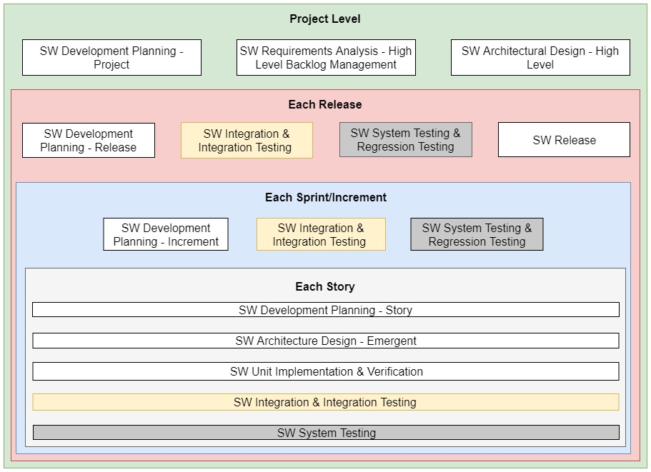

Agile Development & Software Documentation
The solution is to have a short phase of reflexion/sprint zero (in agile terms) at the beginning of the development, to draw a sketch of the architecture of the software, its main functions and its intended use. Then, the iterations begin, and all documents are updated during iterations.
- Beginning
The beginning of the project is the right time to write documents about the organization and the structure of your project:
- Project Management Plan
- Software Development Plan
- Software Configuration Management Plan
- Risk Management Plan

On having these documents, real technical work begins, they shouldn't change.
Perhaps the project management plan needs an update with a new planning if the initial planning was too short (real life) or too long (dream).

- Reflexion/Sprint Zero
Reflexion is the first iteration where concepts and ideas are cast in a first sketch of software.
The solution is to have a short phase of reflexion at the beginning of the development, to draw a sketch of the architecture of the software, its main functions and its intended use. Then, the iterations begin, and all documents are updated during iterations.
This phase of reflexion is like the sprint zero, which aims at initializing the backlog.
- Software Requirements Specifications: the functionalities,
- System Architecture Document: General architecture of your software,
- Software Test Plan: Organization of tests and resources needed to test it.
- Usability Specifications Document: the man machine interface,
- Risk Analysis Report: Risks and mitigations of known functionalities,
All documents above shouldn't be 100% complete at the end of reflexion phase. They only should be filled with what you know of your future software, so far.
- Iterations
Software becomes more and more mature at each iteration. The documentation shall reflect this maturity. Thus, update documents initialized during reflexion:
- Software Requirements Specifications: Update the list of functionalities,
- System Architecture Document: Update and stabilize the general architecture of your software,
- Software Test Plan: Update organization of tests and resources needed to test it.
- Usability Specifications Document: update the man machine interface,
- Risk Analysis Report: update risks and mitigations of known functionalities,
And as the software becomes more and more mature, create new documents that are relevant of this maturity:
- Software Detailed Design: when design is stabilized,
- Software Test Description: when software functionalities don't change,
- Software Test Report: when functionalities are testable,
- User Guide: as soon as you can (it is the poor relation in the documentation).

The software documentation previously initialized is updated on the fly, according to the content of the current iteration. Not all documentation should be updated at each iteration, hence some iterations may only contain bugs fixes and some others may contain brand new user requirements.
We choose the parts of the cycle you should do in the iteration, given the content of the backlog you implement. This is represented in the image below (this is not a representation of an iteration).

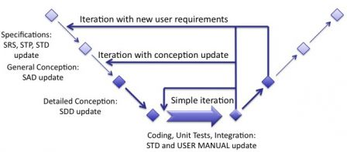
If an iteration contains only bugs fixes, then almost no documentation should be updated. Perhaps, only detailed conception or a bit of architecture, and if necessary a small test case to verify a bug fix. If an iteration contains software requirements, then the SRS and all other documents shall be updated.
- Consolidation
At the end of the iterations, a consolidation phase is necessary to ensure that every technical requirement, every functional requirement, and the intended use are well implemented by the software. This consolidation is nothing else than a tests phase where the whole software is tested from A to Z. A consolidation should not be very long, since everything was already defined and tested before. This phase aims only at ensuring that there was no hole in the mesh of your iterations (holes = remaining bugs, most of times).
The tests phases shall be the classical ones: unit tests, functional tests and use cases tests.
The consolidation is a phase with tests and bugs fixes, not new functions. The following documents shall be ready to do tests.
At the beginning of consolidation:
- User Guide: how to use your software,
- Software Test Description: how to test it,
- Version Description Document: a revision before tests.
At the end of consolidation:
- Software Test Report: the results of tests
- Version Description Document: a revision after tests.

2.2 Process Flowchart

Beginning

Consolidation

Sprint Zero

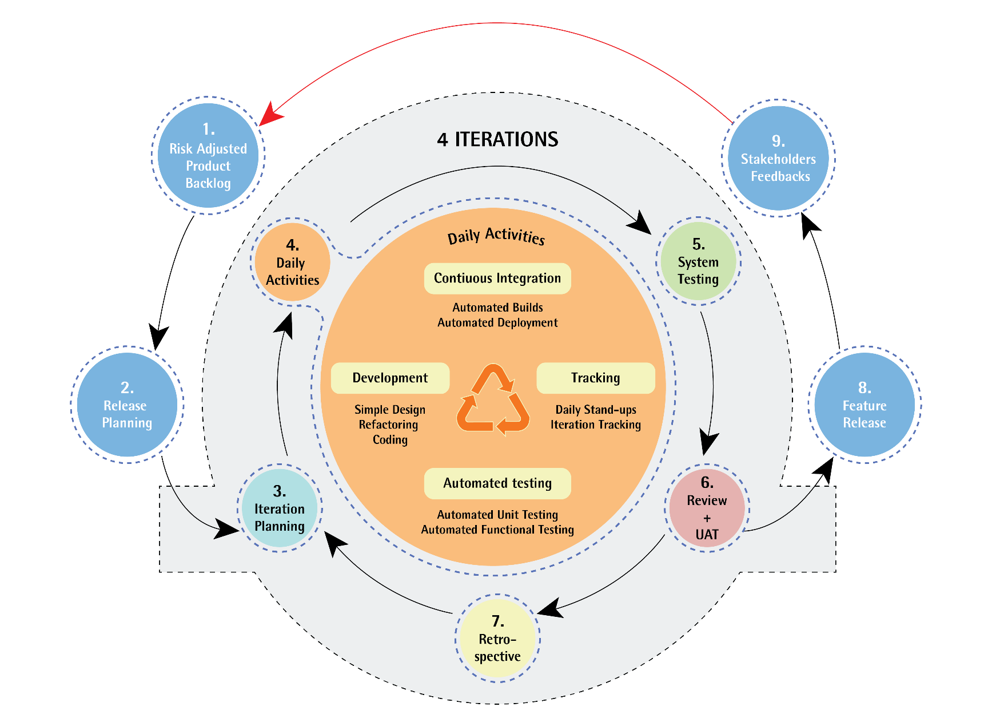

2.3 Description of Tasks

Beginning

Software Development Planning
The development plan is used to define,
- process to be used
- which role, until when, must create which (software) artefact.
- Deliverables
- Software Configuration & Change Management
- Software Problem Resolution.

Input
The following documents serve as input for this activity:
- Product Description [TD_PD]
- Template “Software Development Plan” or Template “Software Maintenance Plan”

Description of activity
The development or maintenance plan should include:
- The assignment of team members for roles in tabular form
- Optional: A project charter to list down tasks and assign team members
- Optional: A project / milestone plan with due dates and results, e.g. Gant chart
- Optional: Additions or changes to this SOP in terms of tools, coding guidelines or additional roles
- Deviations from the standard configuration management
- In the case of software maintenance selection of tickets that are actually included in the release
- Optional: Cost estimate for the tickets
- Optional: Assignment of the tickets to individual software developers
- Planned version number and scheduled release date of the software
- For Additions and changes, a check which activity, e.g. risk management or documentation steps are required to be updated. Especially risk management should be always checked.

Output
The following documents are generated or updated in due course of this activity:
- Signed Software Development Plan [TD-SDP] or Software Maintenance Plan [TD-SWP] which includes the modification approval
- List of tickets that should incorporated into the next release

Writing Risk Management Plan
- See SOP Risk Management

Sprint Zero

Specifying the Requirement

Stakeholders Requirements

Input
The following documents serve as input for this activity:
- Product Description [TD-PD]
- Optional: Template “Stakeholder Requirements”
- Risk Management File [TD-RMF]

Description of activity
The following steps are to define the stakeholder requirements:
- Identify stakeholders and define user profiles
- Describe core tasks
- Identify Stakeholder Requirements
Identify stakeholder and define user profiles
The stakeholder is identified by groups, such as user group “physician”. This user group is the most important to acquire stakeholder requirements. Nevertheless, there are also list other stakeholders, such manufacturer group “general management”.
Note: The user groups are already defined within the intended use description. New insights may require an update of the intended use document [TD-IU].
Identify Stakeholder Requirements
The stakeholder requirements ideally are derived from stakeholder needs. At least the following types of stakeholder requirements are distinguished:
- User requirements
- Regulatory requirements
- Specific requirements
- Market requirements
- Organizational requirements
User Requirements shall be grouped by core tasks.
All stakeholder requirements must have a unique ID.

Output
The following documents are generated or updated in due course of this activity:
- Product Requirements Verification Validation Table [TD-PRVVT]
  - Stakeholder requirements [TD-SHRS]
  - Stakeholder Requirements Review Checklist [FOR-SHRC]
- Product Description (conditionally updated) [TD-PD]

System Software Requirements Specifications

Input
The following documents serve as input for this activity:
- Product Requirements Verification Validation Table [TD-PRVVT]
  - Stakeholder requirements [TD-SHRS]
- Software Development Plan [TD-SDP]
- Product Description [TD-PD]

Description of activity
The following steps are performed to define the software requirements:
- Description of use scenarios and primary operating functions (usability specification)
- Description of software as black box / software requirements
- Verification and approval
  - Trigger Risk Management for safety related requirements
  - Trigger Risk management for safety classification
  - Quality check and approval
Description of Use Scenarios & Primary Operating Functions (usability specification)
The use scenarios for each core task are defined to ensure a complete description of the user interface.
Each use scenario is named after the core task. The core task is subdivided into sub-tasks and each sub-task is described with one or more pairs of user action and corresponding system response and related user requirements. Furthermore, each sub-task is classified as safety related or frequently used, which later is required to identify their functions and thereby to define the primary operation functions. Optionally obvious software requirements are identified and documented.
Description of Software as Black Box / Software Requirements
The system/software requirements are specified by describing the software as a black box. The followings are described:
- the user interface with its static properties (e.g. with mock-ups) and dynamic behaviour. The user interface specification is derived from the user requirements, core tasks and use scenarios.
- the system-system interfaces by addressing the four levels of the interoperability model (structural, syntactic, semantic and organizational interoperability)
- the run-time environment in particular hardware (CPU, RAM, screen sizes and resolution if applicable), operating system and other software as browsers, run-times like .NET, JRE, firewalls etc. (but not SOUPs!)
For requirements that are enforced for various functions or components, generic requirements are considered as style guides to avoid documenting system/software requirements redundantly.
In maintenance mode, the software requirements may correspond to the tickets if the tickets describe the software respectively. The change is using the black box model.
All requirements or specifications addressing a risk reduction measure (Requirement Source = risk management) are documented in the Risk Assessment Table
The system/software requirements are documented using the template TD-SRS.
All system/software requirements must have a unique ID.
Verification and Approval
The following verification activities are used to ensure high quality software requirements.
Step 1: Risk Management
The risk management activities mentioned in SOP: 0700_000_Risk Management are triggered to ensure, that all safety related use scenarios are covered by the risk analysis. In particular, it is ensured that each function (task objects such as tables and tools such as buttons) or at least each screen is considered, including an analysis, what would happen if the user enters, selects or understands something wrong.
Additional software requirements resulting from risk management, such as risk reduction measures, are included in the Software Requirement Specification.
In maintenance mode, the risk analysis and risk-minimizing measures are limited to the changed parts of the user interface.
The risk analysis is enhanced by analysing the hazards that arise from the System-System Interfaces or the runtime environment transfers data in and out incorrectly, in the wrong order, in the wrong time or falsified. The results of the PHA are documented in the risk management file.
Step 2: Verification
Based on the provided use scenarios, safety classification is defined according to IEC 62304. If there is no other definition, the safety class is IIa by default.
The software requirements are checked for completeness (e.g. considering all types of interfaces, e.g. using the criteria of the ISO 25010, on implementation of all stakeholder requirements) and to formal aspects.
The form "Software Requirements Review Checklist" [FOR-SWRC] is used for the documentation.

Output
The following documents are generated or updated in due course of this activity:
- Product Requirements Verification Validation Table [TD-PRVVT]
  - Usability Specification/File [TD-UF]
  - Software Requirements Specification [TD-SRS]
  - Software Requirements Review Checklist [FOR-SRC]
- Risk Management File [TD-RMF]

Documenting the Software Architecture

Input
The following documents serve as input for this activity:
- Product Requirements Verification Validation Table [TD-PRVVT]
  - Stakeholder Requirements Specification [TD-SHRS]
  - Usability Specification/File [TD-UF]
  - Software Requirements Specification [TD-SRS]
- Software Development Plan [TD-SDP]
- Risk Management File [TD-RMF]

Description of activity
Creation of architecture and detailed design
A software architecture is designed including the detailed design that fulfils the stakeholder as well as the software system requirements, the activities includes:
- model the static structure for the first (Class B) and the first two (Class C) levels of building blocks at least using UML component or/and class diagrams. I.e. the software units according to IEC 62304 correspond to the second level building blocks/components
- describe for each software unit/component the API e.g. the signatures of public methods with parameters, return values, value ranges and exceptions
- identify the SOUPs in these diagrams using the stereotype «SOUP»
- describe the integration test strategy
- if applicable describe the database scheme e.g. using ER-diagram or DLL (name of table and columns, data types, primary and foreign keys)
- describe the dynamic structure e.g. via UML timing, sequence or activity diagrams (this step is optional only for “non-FDA projects”)
- optionally describe the deployment view e.g. using UML deployment diagrams
- determine programming language(s) and other technologies to be used
The software architecture is documented using the template [TD-SA].
Verification and Approval
Step 1: Risk Management
The risk management activities mentioned in SOP: 0700_000_Risk Management are triggered to ensure that all risks are analysed, which may arise from the choice of architecture including the choice of SOUPs.
The results of the risk analysis initially and after analysis of new architecture may provide new input for the software architecture through risk reduction measures or corresponding requirements. The affected documents should be updated accordingly.
Step 2: Verification
The software architecture is verified for:
- completeness: e.g. static view described, all system requirements addressed and traceability
- formal aspects in terms of the aspects mentioned above
The verification is documented using the form “Software Architecture Review Checklist” [FOR-SARC].

Output
The following documents are generated or updated in due course of this activity:
- Software Architecture [TD-SA]
- Software Architecture Review Checklist [FOR-SARC]
- Risk Management File [TD-RMF]

Iterations

Risk adjusted product backlog
Risk adjusted product backlog is used to define major user requirements (stories) sorted according to their business priority and risk involved.

Input
The following documents serve as input for this activity:
- Product Requirements Verification Validation Table [TD-PRVVT]
  - Stakeholder Requirements Specification [TD-SHRS]
  - Usability Specification/File [TD-UF]
  - Software Requirements Specification [TD-SRS]
- Risk Management File [TD-RMF]
- Change requests
- Description

Description of activity
Usually user stories in the backlog are ranked (by Product owner) focusing on the business priority / value for the customer. But this does not account for the project risks. Hence, we need to create a risk adjusted product backlog.
By the term risk, here, it always means Project Risks, and different from Medical Device Risk Management.
All stakeholders participate in creation of the risk adjusted product backlog.
Following process is applied:
- Stakeholders make a product backlog prioritized by business value.
- Stakeholders identify all possible risks for the project.
- Stakeholders assign an impact and probability to each of the risk item.
- Stakeholders calculates risk severity (Risk Severity = Impact * Probability)
- The resulting list is sorted by risk severity.
- Risk adjusted product backlog is created by combining outputs of step 1 and step 5
- Documentation (Update, if required)
  - Software Development Plan
  - Product Requirements Verification Validation Table [TD-PRVVT]
  - Software Architecture [TD-SA]

Output
Risk adjusted Product backlog

Release planning
A very high-level (course grained) plan for multiple sprints/iterations is created during the Release planning. It is a guideline that reflects expectations about which features will be implemented and when they are released

Input
- Feedback from stakeholders on the product, market situation, and deadlines
- Risk adjusted product backlog
- Development and architecture information
- Velocity from previous iterations and releases
- Organizational and personal calendars
- Input from other teams and subject matter experts to manage dependencies
- Fixed count of iterations for all releases

Description of activity
Release planning should be initiated based on the inputs mentioned above
- Scrum master, product owner, development (agile) team, and stakeholders will be key members for setting up the release plan
- In this activity we will create or update a release plan for future releases
- A release plan can be duration driven or feature driven
- The following points influence the creation of release plan
  - Analysis of feedbacks from stakeholders
  - Analysis of actions plans and goals
  - Risk adjusted product backlog
- Emergent technical issues, development challenges, dependencies connected with feature items and defects.
- A release plan will also document what documents need to be updated.

Output
- Release plan
- Issues, concerns, dependencies, and assumptions to be monitored
- Suggestions to improve future planning meetings

Iteration planning
The purpose of the iteration planning, is to enable the development team to pick up items from the prioritized product backlog and make an iteration backlog. The development team then commits to the delivery of this iteration backlog at the end of the iteration.
The size of the iteration backlog is based upon the team's velocity or capacity and the duration of the iteration.

Input
- Release plan
- Prioritized product backlog items
- Input from other teams and subject matter experts to manage dependencies
- Duration of the iteration

Description of activity
- Scrum master, product owner, and development team will be part of this activity
- In this activity we will create a sprint backlog consisting of items from prioritized product backlog
- The team periodically estimates the size of a user story, when it is first created, during backlog refinement sessions, and before the planning meeting
- Backlog refinement sessions can be conducted multiple times in the lifetime of each iteration.
- The team also analyses the past velocity to determine what quantity of product backlog items to commit to during the iteration
- Calculate the available team capacity for the iteration.
- The items in the product backlog will be sized by the team based on discussion of each story, elaborate acceptance criteria, and provide estimates.
- The team determines the tasks necessary to complete each product backlog item.
- Task owners estimate the ideal hours they need to finish each task.
- Plan the documentation tasks and estimate the time required for updating the documentation.

Output
- Iteration plan is a subset of the prioritized product backlog and release plan
- Commitment by the development to the iteration plan
- Transparency for all stakeholders about the work to be done in current iteration

Daily activities
Scrum team has multiple actions to be performed on a daily basis. The Scrum team consists of Scrum master, product owner and development. The primary actions on a daily basis are Development of the product increment, Tracking, Continuous integration and automated testing which consists of unit testing and integration testing

Development of product increment (Implementation)

Input
- Tasks from iteration plan
- Runtime modifications in the tasks due to resource unavailability

Description of activity
- Design, code and make ready the tasks allotted to the development team
- Test the work as per the given requirements.
- Code Review and Checking the Code Standards

Output
- Completed tasks of the iteration plan

Tracking

Input
- Discussions from daily stand-up meetings
- Output of Scrum of scrum meetings (meeting held to synchronize various teams working on the same project)
- Sprint backlog
- Product backlog
- Impediments (any problems or issues)

Description of activity
- Conduct daily stand-up meetings, which inspect the progress and adapt any lags observed in progress towards the iteration goal.
- Daily stand-ups are quick time boxed meetings which answer four questions, one being what I did yesterday, second being what I will do today, third being do we have any impediments in our progress and the fourth being as a team are we on target
- Additionally, a scrum of scrum meeting is conducted for larger ventures, representatives of various teams of the same project gather together to synchronize their progress and impediments.

Output
- Confidence and clarity about success of the sprint goal
- Clarity and transparency for all stakeholders

Continuous integration
Continuous integration (CI) is a software development practice that requires team members to integrate their work frequently. Every person integrates at least daily, which leads to multiple integrations each day. Automated scripts check the integrated code for regression. Continuous integration helps detect integration problems earlier on and thus increasing chances of project success

Input
- Code build committed by the developers to the code repository
- Set of test cases for unit tests, integration tests and regression tests

Description of activity
- Continuous integration tool e.g. Jenkins is installed in the development/test environment
- Continuous integration tool facilitates the platform for doing the automated unit and functional testing of the software
- Plugins for code repository administration, static code analysis, automated testing frameworks, automated reporting and automated deployments will be configured and administered inside the Continuous integration tool
- Continuous integration tool automates all of the above tasks and delivers the output in the form of reports on automated testing scripts, static code analysis, reporting of the build status and deployment of the build (working software) to staging or production environments.

Output
- Working software increment

Automated testing
Automated testing is a critical component to maintaining agility, and is a priority for the entire team through established practices/disciplines and a focus on continuous improvement

Input
- Working software code and suit of test cases including unit and integration tests
- Testing framework tools

Description of activity
- Automated testing is applied on working software repeatedly to validate and verify the working of the code resulting correct working of the software
- Testing of the modules/components code at functional level is achieved with the help of unit test cases.
- Testing of the interconnection between the modules is achieved with the help of integration tests
- Continuous integration will facilitate the automation of the execution of the developed unit and integration tests
- Automated testing facilitates the quality control process of the software modules.

Output
- Tested working software increment

System Testing
System Testing is a level of the software testing where committed and integrated software is tested. The purpose of this test is to evaluate the system’s compliance with the specified requirements. “How does the recently released code work/interact with the entire system”

Input
The following documents serve as input for this activity:
- Working increment from recent iteration
- Product Requirements Verification Validation Table [TD-PRVVT]

Description of activity
- The entire software system is tested against the software requirements.
- The system test may include testing (verifying) of risk reductions measure
- The test codes are kept under version control and the test reports e.g. log files are stored.
- There are several types of System Testing. Major once are listed below. These are the most used types of System testing. We choose the applicable types based on the software increment. Thus, not all of the following testing are conducted for every software increment.
- Usability Testing - Usability Testing mainly focuses on the user's ease to use the application, flexibility in handling controls and ability of the system to meet its objectives
- Load Testing - Load Testing is necessary to know that a software solution will perform under real-life loads.
- Regression Testing - Regression Testing involves testing done to make sure none of the changes made over the course of the development process have caused new bugs. It also makes sure no old bugs appear from the addition of new software modules over time.
- Recovery Testing - Recovery testing is done to demonstrate a software solution is reliable, trustworthy and can successfully recoup from possible crashes.
- Migration Testing - Migration testing is done to ensure that the software can be moved from older system infrastructures to current system infrastructures without any issues.
- Functional Testing - Also known as functional completeness testing, Functional Testing involves trying to think of any possible missing functions. Testers might make a list of additional functionalities that a product could have to improve it during functional testing.
- Hardware/Software Testing - In this testing, the tester focuses his/her attention on the interactions between the hardware and software during system testing.

Output
- Test exit report
- Updated Product Requirements Verification Validation Table [TD-PRVVT]

Review and User acceptance testing (UAT)

Review
In Review, the Scrum Team and stakeholders collaborate about what was done in the Sprint. It is a review of the working increment of the software against the Product Backlog.

Input
- Working increment of software
- Release plan
- Product Requirement Verification Validation Table [TD-PRVVT]
- Iteration plan
- Product Backlog

Description of activity
The Sprint Review includes the following elements:
- The Development Team demonstrates the work that it has “Done” and answers questions about the Increment;
- The entire group collaborates on what to do next, so that the Sprint Review provides valuable input to subsequent Sprint/iteration Planning;
- Review of how the marketplace or potential use of the product might have changed what is the most valuable thing to do next;
- Review of the timeline, budget, potential capabilities, and marketplace for the next anticipated releases of functionality and capability of the product.

Output
- Release document
- Refined product backlog
- Working software increment

User acceptance testing (UAT)
User acceptance testing happens once the development team along with the product owner is satisfied with the work done in the sprint.
The user acceptance test is performed with the customer or with end user of the system.
In user acceptance test, end user checks all his requirements with the system in hand.
The goal of the User Acceptance Testing is to assess if the system can support day-to-day business and user scenarios and ensure the system is sufficient and correct for business usage

Input
- Product Requirements Verification Validation Table [TD-PRVVT]
  - Software requirement specification
- Executable code (working increment)

Description of activity
- The intended user of the system performs UAT, it is also called as Beta testing since it is done at the location of the end user.
- UAT is done to ensure that no critical defects are open, Business processes are working according to the user expectation
- Best Practices of performing UAT
- Conduct Pre-UAT session during System Testing phase itself
- Set the expectation and define the scope of UAT clearly
- Test End to End business flow and avoid system tests
- Test the system or application with real world scenarios and data
- Think as an Unknown user to the system
- Perform Usability Testing
- Conduct Feedback session and meeting before moving to production.

Output
- UAT acceptance sign off from stakeholders

Retrospective
A retrospective is held at the end of each iteration for the team to inspect and adapt their iteration, teamwork, and methods. The scrum master facilitates the ceremony to ensure that all members participate openly. Retrospective may focus on to embrace new scrum practices that increase the efficiency of team and work processes, solution to the problems incurred during the iteration, and continuous improvement in the people, processes and product.

Input
- Reviewed iteration

Description of activity
- Scrum master go beyond asking what worked well and what didn't work well in helping teams gather insights about their practices
- Ask each of these questions individually and have the team identify items to be noted down
  - What helped us in this iteration?
  - What hindered us in this iteration?
  - What hypotheses (recommendations) could we make about how we work in our next iteration?
- An iteration retrospective is a great time to invite individual team members to appreciate other individual team members and develop the good working environment
- Generate action items for the continuous improvement of people, process and product.

Output
- Completion status of the iteration
- Feedback about the incurred issues, process problems, individual and team achievements
- Possible action items for next iteration

Stakeholders feedback
- Once the software or a feature is released for client/End user we need to Check if changes to the software/feature are required
- If such change request received from end user, all stakeholders need to analyse changes, feasibility and risk involved and then accordingly add the change to the product backlog

Input
Any of the following sources may serve as input:
- Customer complaint/Customer request/feature request
- Update of a regulation e.g. standard, law, guidelines or technology
- Observation by development team
- Results from internal or external audits, requests by authorities
- Critical incident with the product, comparable product or product based on same technologies or principles
- Any other information e.g. post-market clinical follow-up
- Check section “2.1.5 Sources of Complaint or Feedback” of Customer Support 0900_000_SOP Customer Support, Feedback & Complaint Handling for more details

Description of activity
The following information is documented (if possible and applicable):
Information to reproduce and solve problem which may include the following
- Software version
- Description of problem optionally including screenshots, log files etc.
- Steps to reproduce the problem
- Run-time environment e.g. device, hardware, operating system
- Proposal how to solve problem, this can include mock-up screens, textual descriptions or any other information relevant to stakeholder or system requirements specification or implementation
Information to classify problem:
- Role detecting the problem (user, own staff, other)
- Criticality in terms of risks for patient, users and others. Description of hazards
- Priority (how urgent the problem needs to be solved), due date
- Type of problem (algorithm, usability, reliability)
- Type of request (complaint/bug, suggestion, other)
- When problem was introduced (specification, architecture, programming)
Required or proposed actions (and decision whether to do something at all)
- Change Software to fix bug and/or to mitigate risk
- Inform authorities (e.g. according to MPSV)
- Inform patients or/and customers

Output
- Updated risk adjusted product backlog

Consolidation

Validating the Software
This section applies for stand-alone software only as embedded software cannot be validated, but only the medical device entirely.
Validation of stand-alone software corresponds mainly to the validation of the usability which is the focus of this SOP.
The validation of algorithms (if required at all) is scope of the clinical evaluation, which is covered by SOP: 1700_000_Clinical Evaluation.

Input
The following deliverables e.g. documents serve as input for this activity:
- Software system, the executable code
- Product Description [TD-IU]
- Product Requirements Verification & Validation Table [TD-PRVVT].
    - Stakeholder Requirement Specification (include core tasks) [TPL-SHRS]
    - Usability File include use scenarios [TD-UF]
    - Software Requirement Specification [TD-SRS] include user interface definition
    - Template Software Usability Validation Plan [TPL-SUVP]
    - Template Software Usability Validation Report [TPL-SUVP]
- Risk Management File [TD-RMF]

Description of activity
The following steps are required to validate the (entire) Software System including usability validation:
- Prepare a software validation plan including acceptance criteria
- Execution of software validation and documentation
Prepare a software validation plan including acceptance criteria
A validation plan includes the acceptance criteria is defined.
The usability validation plan shall cover all safety relevant use scenarios and thereby the corresponding core tasks. The acceptance criteria have to include the post-conditions for each of the core tasks / use scenarios. These post-conditions have to be met completely and correctly.
The usability validation plan shall include all user groups that are assigned to each of the safety relevant use scenarios respectively core tasks. The number of test users per user group and the environment for the usability test that is representative for the actual environment (can be a usability lab) are determined.
It is expected that 100% of users can complete the safety-critical tasks and 80% of users can complete the non-safety-critical tasks. The time to finish the task does not have to be an acceptance criterion.
If there is a deviation for a specific product from these default values, the values are documented with a short explanatory note in the product-specific development plan.
Execution of software validation and documentation
The software validation include usability validation is executed in accordance with the validation plan.
The actual participant’s details are documented:
- User group
- Job title
- Education
- Job experience
- Typical working environment
The quantitative results for each test scenario and participant are documented:
- Execution time (execution time in minutes)
- Support needed (yes / no)
- Result completely achieved (yes / no)
- Results achieved properly (yes / no)
The results are summarized and considered whether
- The efficiency of utilization is impaired
- The efficiency of use is impaired
- There are risks for patients, users or other, caused by the usability
If there are remaining risks, the risk management file should regularly update accordingly with reference to SOP: 0700_000_Risk Management.
In case of change in the GUI, the Product Manager and the Risk Manager need to assess whether a new usability validation must be performed.

Output
The following documents are generated or updated in due course of this activity:
- Software Usability Validation Plan [TPL-SUVP]
- Software Usability Validation Report [TPL-SUVP]
- Risk Management File [RD-RMF]

Release the Software

Input
The following documents serve as input for this activity:
- Product Description [TD-PD]
- Product Requirements Verification Validation Table [TD-PRVVT]
- Stakeholder Requirements Specification [TD-SHRS]
- Stakeholder Requirements Review Checklist [FOR-SHRC]
- Software Requirements Specification [TD-SRS]
- Software Requirements Review Checklist [FOR-SRC]
- Software Architecture [TD-SA]
  - Software Architecture Review Checklist [FOR-SARC]
- Software
  - Source code and other artefacts, code binary
  - Executable code and other artefacts
  - Test scripts
- Unit Test Results
  - Component (unit) Test Report [AR-CTR]
  - Static Code Analysis Report [AR-SCAR]
  - Code Review Checklist [FOR-CRC]
- Software System Test Plan [TPL-STP]
  - Software System Test Report [TPL-STR] include usability verification (inspections), include log files, unit test reports or other automated reports from integration tests and system tests
  - Remaining Anomalies Report [AR-RAR]
- Software Usability Validation Plan
  - Software Usability Validation Report
- Risk Management File [TD-RMF] and clinical evaluation
- User Documentation/Manual, labelling
* External input not part of this SOP Software Development

Description of activity
The goal of this activity is not to verify the software but the compliance of the process and thereby the documentation with the regulations, especially the applicable SOPs:
- This SOP
- 0700_000_Risk Management
- Technical File
- 2200_000_Conformity Assessment
- Other applicable SOPs
This compliance is checked by evaluating whether
- all required documents (see “Input”) exist
- all these documents are filled out correctly (at least based on examples)
- the remaining anomalies are evaluated acceptable
- all artefacts are under version control respectively achieved on a DVD or server (both, outside the development building)
- the software has a three level version number <MajorReleaseVersion.MinorReleaseVersion.PatchVersion> and an assigned build number
- all tests are reproducible
- there is an (updated) user manuals and if required an installation respectively operation manual
- the CE marked is visible (if applicable) at the splash screen, in menu “help/about”, on DVD, in user manual
- there is a release note (with respective version number) listing all improvements, bug fixes and other changes
These activities are documented using the Software Release Checklist [FOR-SRC].

Output
The following documents are generated or updated in due course of this activity:
- Software Release Checklist
- Revised Risk Management File, if necessary [TD-RMF]

Product Release

The product release is described in the SOP: 0800_000_Product Release.

Problem Resolution Process
After an initial release, any feedback and any change to the software are handled via this variation of the software development process.

Post Production Feedback Analysis
The targets of this activity are:
- judge whether changes to the software are required
- judge whether an escalation is required e.g.
  - information of authorities, customers, patients
  - product recall
- analyse trends
- decide on protective actions
- decide if content update is needed to accommodate legal changes (example a drug has been banned from sale, a new drug has been released for sale etc.)

Input
Any of the following sources may serve as input:
- Customer complaint (in written, verbally, Appstore comments, feedback emails sent from app)
- Customer request/feature request (in written, verbally. Don’t confuse with customer/user requirement)
- Update of a regulation e.g. standard, law, guidelines
- Observation by employees (development, product management etc.)
- Results from internal or external audits, requests by authorities
- Critical incident with the product, comparable product or product based on same technologies or principles
- Any other information e.g. from post-production analysis respectively post-market clinical follow-up
- Check section “2.1.5 Sources of Complaint or Feedback” of Customer Support 0900_000_SOP Customer Support, Feedback & Complaint Handling for more details

Description of activity
The following information is documented (if possible and applicable):
- Information to reproduce and solve problem:
  - Software inclusively version
  - Description of problem optionally including screenshots, log files etc.
  - Steps to reproduce problem
  - Run-time environment e.g. device, hardware, operating system
  - Proposal how to solve problem, this can include mock-up screens, textual descriptions or any other information relevant to stakeholder or system requirements specification or implementation
- Information to classify problem:
  - Role detecting the problem (user, own staff, other)
  - Criticality in terms of risks for patient, users and others. Description of hazards
  - Priority (how urgent the problem needs to be solved), due date
  - Type of problem (algorithm, usability, reliability)
  - Type of request (complaint/bug, suggestion, other)
  - When problem was introduced (specification, architecture, programming)
- Required or proposed actions (and decision whether to something at all)
  - Change Software to fix bug and/or to mitigate risk
  - Update Risk Management File
  - Inform authorities (e.g. according to MPSV)
  - Inform patients or/and customers
  - Change SOPs, improve training, improve manual
- Assessment of efforts
These data are recorded in the ticketing / bug management system.

Output
The following documents are generated or updated in due course of this activity:
- Filled ticket

Change permission
If the previous activity concludes that a change of the software is necessary, an explicit change permission is required.

Input
The following documents serve as input for this activity:
- Ticket (filled out in previous activity)
- Technical file including requirements specification etc.

Description of Activity
How and which parts of the software must be changed, and which documents have to be updated are analysed. The documents are updated accordingly per the software development process i.e. verifying these documents as described above. The ticket is assigned to a Software Developer i.e. the development team may start implementing right away.
If it is not able to detect what is causing the problem right away, the standard development process should be followed by describing which parts of the system requirements must be changed and which are not fulfilled. The ticket is assigned to the System Architect.
In both cases, the followings are performed:
- approve the change implicitly with the assignment of the ticket
- Add the task to the Risk Adjusted Product Backlog.
- update the assessment of efforts
- optionally define the target software version respectively target release date

Output
The following documents are generated or updated in due course of this activity:
- Optionally updated technical file
- Updated ticket (release date, target version, assignment to next role)

Configuration Management
All artefacts that are created or updated in this process, subject to document control.

Version control
Versioning of the documents is done according to the following scheme:
Document | Versioning
Specification documents e.g.  - this SOP  - Software Requirements  - Software Architecture  - Validation Plan | <MajorReleaseVersion.MinorReleaseVersion>
Records, for example, Completed checklist | No Versioning. Paper
Development artifacts e.g.  - Source code  - Configuration files  - Icons, Images | <MajorReleaseVersion.MinorReleaseVersion.PatchVersion> or  <MajorReleaseVersion.MinorReleaseVersion>
SOUP | <MajorReleaseVersion.MinorReleaseVersion.PatchVersion>

Branching Strategy
Branches are used to assign the various software versions the documents in the versions.

Description of the Activity
The main branch (master branch) has at any time the latest software version which is a protected branch and can only be accessed by master privileged users. For each software version (e.g. extension or troubleshooting) we create stand-alone non-protected branches as temporary clone of the master branch. These branches are assigned to developer privileged users. We develop and we test the changes on standalone branches. After successful testing, developer users create a merge request/pull request and send this request to master user for approval to push and merge the code with master protected branch.
Master user is the administrator of the master branch who reviews the code, solves merger conflicts inside the code by communicating with developer users.
More details are described in the sub-SOP: 0601_000_Version Control with GIT.

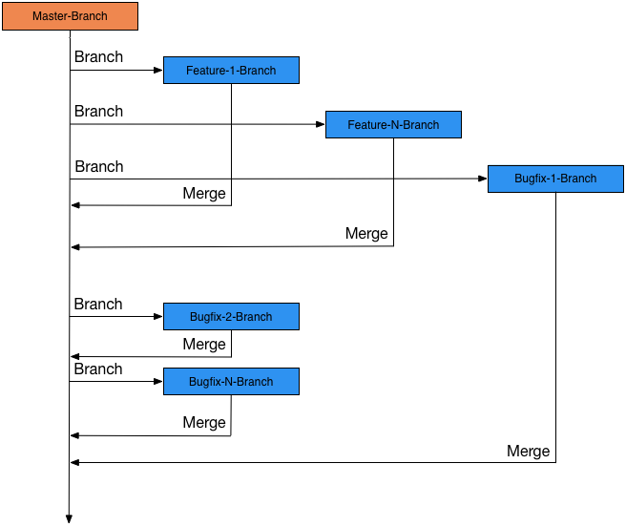
Fig 1: Overview of the branching approach

